SIMATS ENGINEERING (SAVEETHA SCHOOL OF ENGINEERING)
Department of Computer Science and Engineering
CO4 ASSESSMENT TOOL 2 – CI/CD Pipeline Design Exercise
Course Code: | CSA10 / CSA1063 | Course Title: | Software Engineering
CO Assessed: | CO4 | Assessment: | Assessment Tool 2 – CI/CD Pipeline Design Exercise
Weightage: | 20% | Total Marks: | 25
CO4 Statement: | Implement robust testing, quality assurance, and DevOps practices, emphasizing security, reliability, and ethics
Student Name: | M Dhanush Kumar | Reg. No.: | 192525318
Date: | 29-08-2026 | Duration: | 60 minutes

Code of Conduct
I, M Dhanush kumar (Reg. No. 192525318), certify that this submission is my original work and that I have adhered to the guidelines specified for this assessment. I understand that any violation of academic integrity rules will result in disciplinary action.
Signature of the Student: M Dhanush Kumar
CI/CD Pipeline Design – Smart Vertical Farming Automation Platform

1. Project / CI-CD Requirement Analysis
The Smart Vertical Farming Automation Platform continuously monitors hydrogen production, predicts equipment failures, optimizes energy usage, detects safety hazards, generates operational reports, and notifies plant operators. Since the system directly supports plant safety and operational decisions, a CI/CD pipeline is essential for the following reasons:
- Frequent software updates: Sensor logic, prediction models, and dashboards need to be updated regularly without disrupting live plant monitoring.
- Automated testing: Every change must be verified automatically so faulty logic does not reach a live industrial environment.
- Reliable deployment: Updates must be delivered to production in a consistent, repeatable manner to avoid monitoring downtime.
- Safety-related quality checks: Since the platform detects safety hazards, code quality and correctness checks are critical before release.
- Security: Plant data and control interfaces must be protected from vulnerabilities introduced by new code or dependencies.
- Monitoring and rollback: Any deployment issue must be detected quickly and reverted to avoid loss of visibility into plant operations.

2. CI/CD Pipeline Architecture
The pipeline below shows the complete flow from developer commit to production monitoring and rollback for the Smart Vertical Farming Automation Platform.
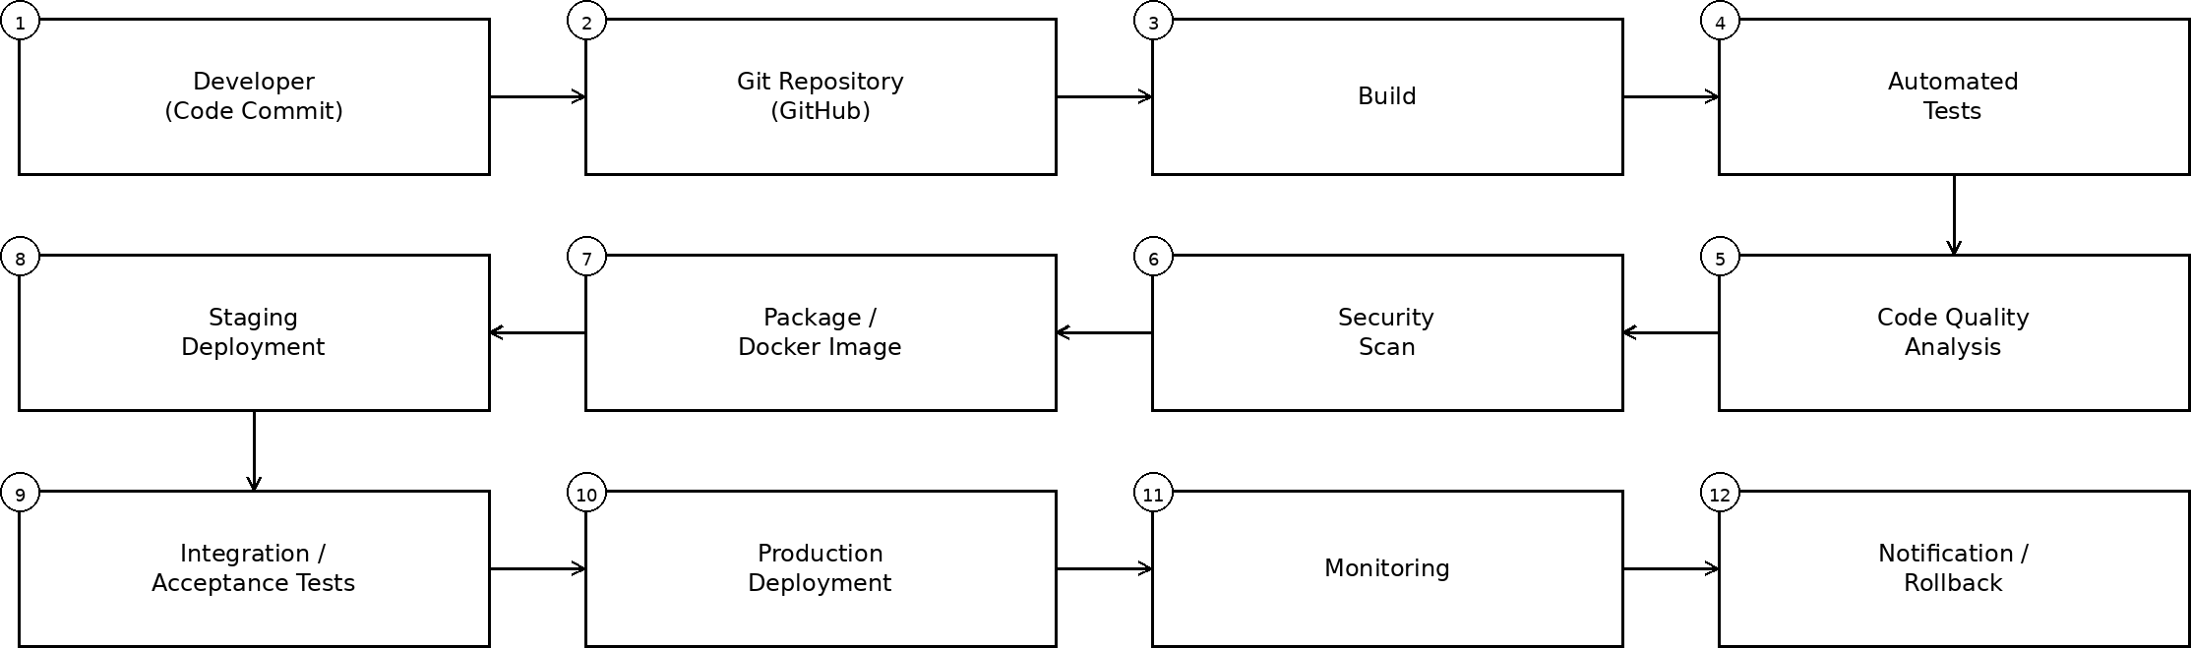
The pipeline follows a linear, automated flow: Developer → Git Repository → Build → Automated Tests → Code Quality Analysis → Security Scan → Package/Docker Image → Staging Deployment → Integration/Acceptance Tests → Production Deployment → Monitoring → Notification/Rollback.

3. Tools and Technologies
A practical and consistent toolchain is selected for each pipeline stage, as shown below.
Stage | Tool | Purpose
Source Control | Git + GitHub | Version control and collaborative development of monitoring and prediction modules.
CI/CD Orchestration | GitHub Actions | Automates build, test, and deployment workflows on every commit.
Build/Packaging | Docker | Packages the application into consistent, portable containers.
Automated Testing | Pytest | Runs unit, integration, and API tests automatically.
Code Quality | SonarQube | Detects code smells, bugs, and maintainability issues.
Security Scanning | Trivy | Scans Docker images and dependencies for known vulnerabilities.
Deployment | Docker Compose / Kubernetes | Manages staging and production container deployments.
Monitoring | Prometheus + Grafana | Tracks plant sensor data pipelines, system health, and alerts.
Notifications | Slack / Email | Alerts operators and developers on build, test, or deployment events.

4. Automated Testing and Quality Checks
Automated tests and quality gates run at multiple stages of the pipeline before any code reaches production:
- Unit testing: Validates individual functions such as sensor data parsing and failure-prediction logic using Pytest.
- Integration testing: Verifies interaction between modules such as the data ingestion service, prediction engine, and reporting module.
- API/system testing: Confirms that monitoring dashboards and notification APIs return correct, timely data.
- Regression testing: Re-runs existing test suites to ensure new changes do not break hazard-detection or energy-optimization features.
- Code quality checks: SonarQube enforces coding standards and flags maintainability issues.
- Security/dependency scanning: Trivy scans container images and third-party libraries for vulnerabilities.
If any critical test, quality gate, or security check fails, the pipeline stops automatically and deployment is blocked until the issue is resolved.

5. Deployment Strategy
Three environments are used to progressively validate changes before they reach the live plant system:
- Development: Developers build and test features locally/in isolated containers.
- Testing/Staging: A production-like environment where integration and acceptance tests validate the build using simulated plant data.
- Production: The live environment monitoring the actual hydrogen production plant; deployment occurs only after all staging tests and security checks pass.
Blue-Green Deployment is selected for production releases. Two identical production environments (blue and current, green and new) are maintained; traffic is switched to the new version only after it passes health checks. This strategy is justified for this system because the monitoring platform must remain continuously available to detect safety hazards — blue-green deployment avoids downtime and allows an instant switch back if the new version misbehaves.

6. Security, Notifications and Rollback
Security
- Secrets management: API keys and credentials are stored in GitHub Secrets, never hard-coded.
- Dependency/container scanning: Trivy scans images before deployment.
- Access control: Role-based access restricts who can approve production deployments.
- HTTPS/API security: All communication with sensors, dashboards, and notification services is encrypted using HTTPS/TLS.
Notifications
- Build failure alerts sent to the development team via Slack/Email.
- Test failure alerts identifying the failing stage.
- Deployment success/failure notifications to operators and developers.
- Critical production issue alerts (e.g., hazard detection failure) sent immediately to plant operators.
Rollback
- The previous stable container image/version is always retained.
- Health checks and monitoring automatically detect failed deployments.
- On failure, the pipeline automatically reverts to the last stable version to restore plant monitoring.

7. Pipeline Workflow
- Developer commits code to the Git repository.
- Repository triggers the CI pipeline via GitHub Actions.
- Dependencies are installed and the application is built.
- Automated tests (unit, integration, API) execute.
- Code quality and security checks execute (SonarQube, Trivy).
- Application is packaged as a Docker image.
- Staging deployment occurs.
- Integration/acceptance tests execute in staging.
- Production deployment occurs (blue-green) after approval and successful checks.
- Monitoring (Prometheus/Grafana) and notifications begin.
- A failed production deployment automatically triggers rollback to the last stable version.

Optional: Sample GitHub Actions Workflow (Illustrative)
A short illustrative workflow snippet is shown below to demonstrate pipeline automation:
name: CI-CD Pipeline
on: [push]
jobs:
build-test:
runs-on: ubuntu-latest
steps:
- uses: actions/checkout@v4
- run: docker build -t hydrogen-monitor .
- run: pytest --maxfail=1

